**Name: Jaffer Momin**

**Date: 9/24/2019 Course: PHYS 2211L Lab: Lab 3**

## Objective:

In this lab we determined the position of multiple objects in 2-dimentional motion by using kinematic equations. We were provided a physics simulation which started with a mathematical model whose variables define the state of the system at a given time. Each variable represents the position or velocity of some part of the system and we were to become familiar with the simulator’s operations. Also, we displayed problem solving techniques as well as the ability to maneuver kinematic equations.

## Theory:

For this experiment I used kinematic equations multiple times to calculate the variables separately because the velocity in one dimension is independent of the other. This lab was separated into vectors, which is a quantity that has both magnitude and direction and was ultimately used to calculate the overall motion.

## Kinematic Equations:

* 1 2

𝑑𝑓 = 𝑑𝑖 + 𝑣𝑖 ∗ 𝑡 + 2 ∗ 𝑎 ∗ 𝑡

* 𝑣𝑓 = 𝑣𝑖 + 𝑎 ∗ 𝑡
* 𝑣2 = 𝑣2 + 2 ∗ 𝑎 ∗ 𝑑

𝑓 𝑖

Variables:

* 𝑑 = 𝑣𝑖+𝑣𝑓 ∗ 𝑡

2

* −𝑏±√𝑏2−4𝑎𝑐

2𝑎

* Vf = Final velocity
* Vi= initial velocity
* Xf= final position
* Xi= initial position
* A= acceleration
* T= time

## Procedure:

Setup: Download the Interactive Physics (IP) software. Step 1: Open the physics simulator

Step 2: Use tools such as rectangular tool, anchor, and circle tool to set up simulation Step 3: Choose an velocity and arbitrary point [ 8m, & 8.26m/s ].

Step 4: Use the 4th kinematic equation to calculate the time it will take for the object to hit the ground.

Step 5: Choose a different point from the first object; [ 12.4 ].

Step 6: Use the 4th kinematic equations to calculate the initial upward velocity plugging in the time calculated from step 3.

Step 7: Plug in all calculated values for each object.

Step 8: Test values – pause simulation close to desired time and click forward slowly to measure exact time.

## Data & Calculations:

**Part 1**

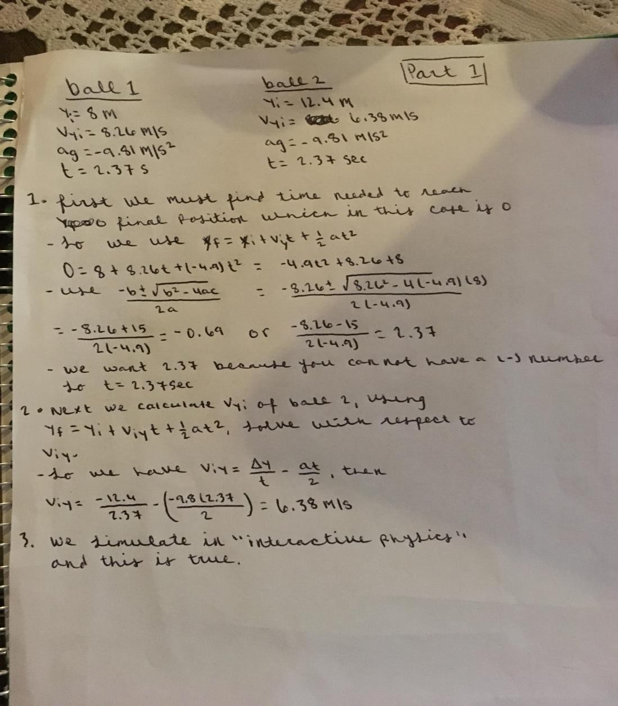

**Part 2**

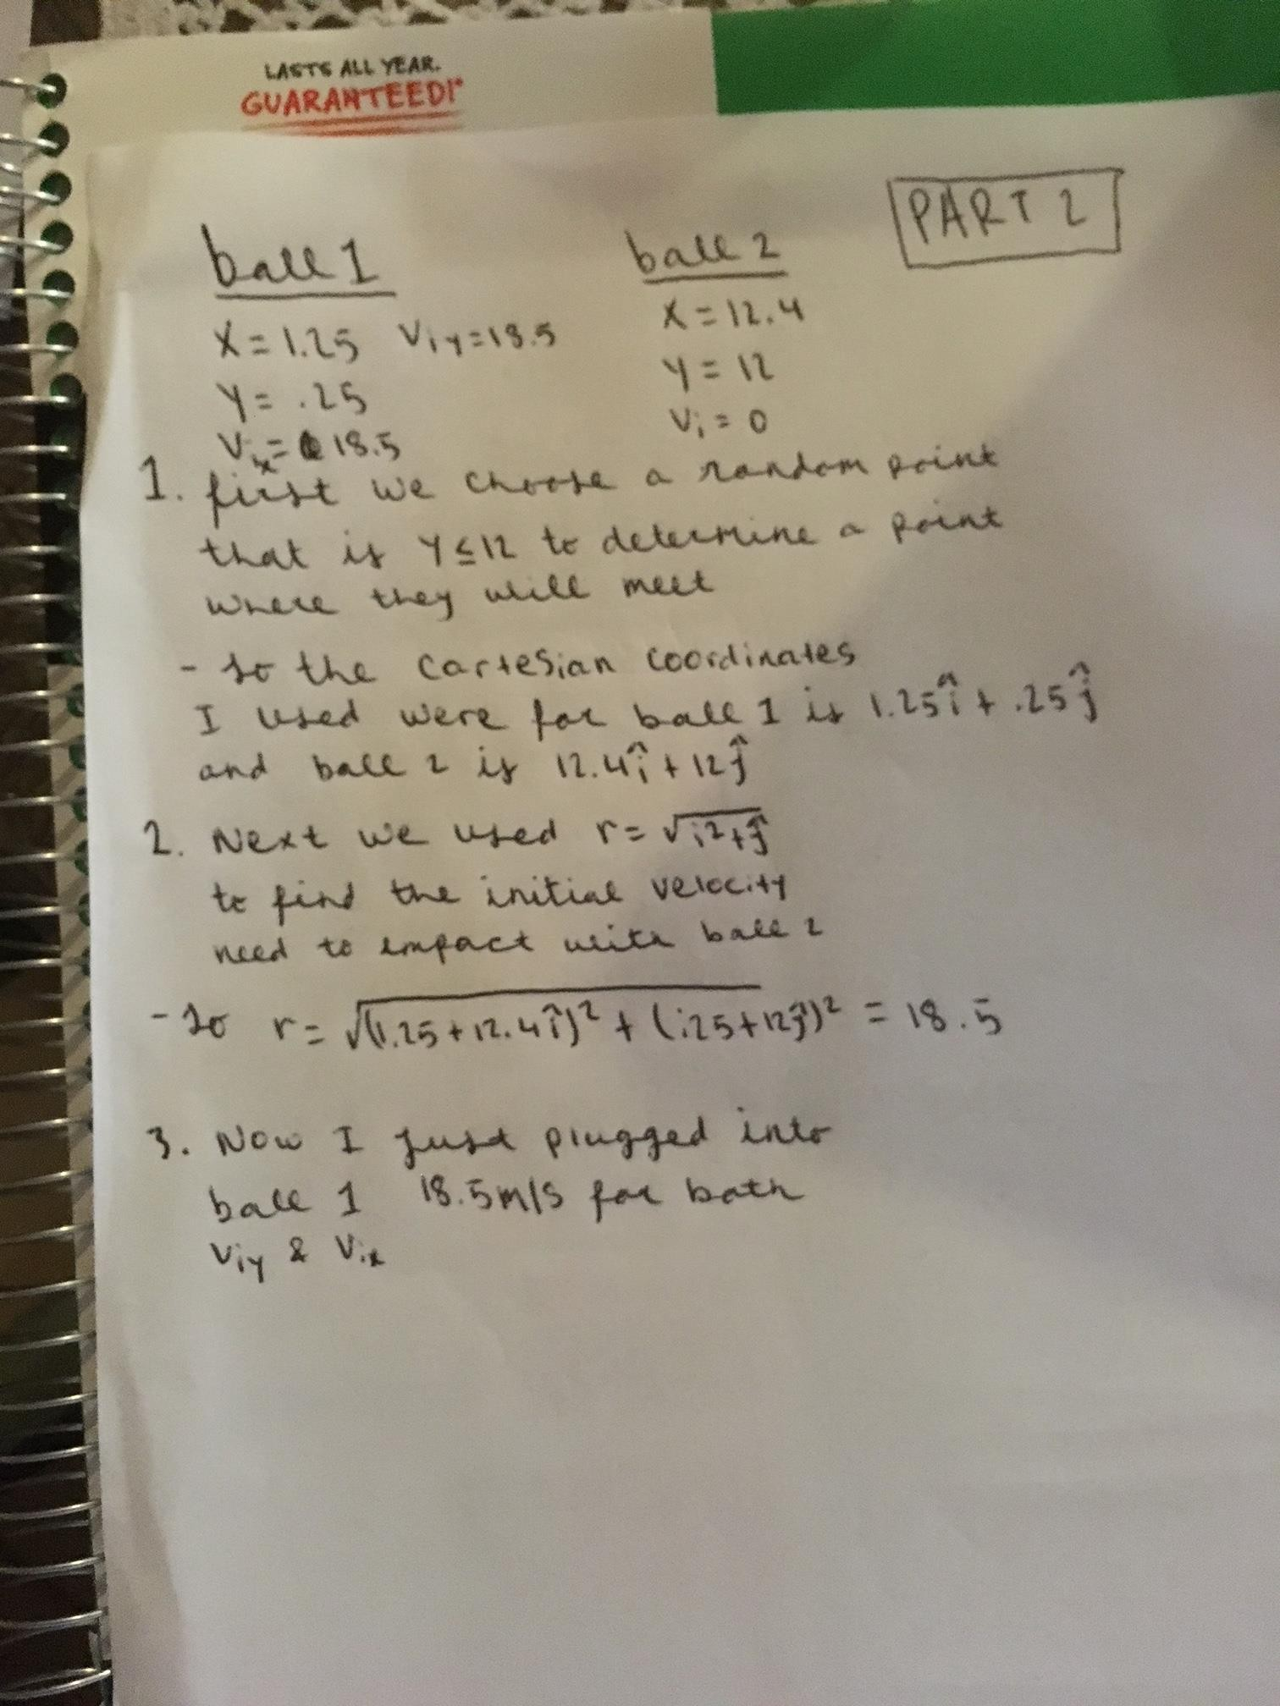

Results: Part 1

# Starting position:

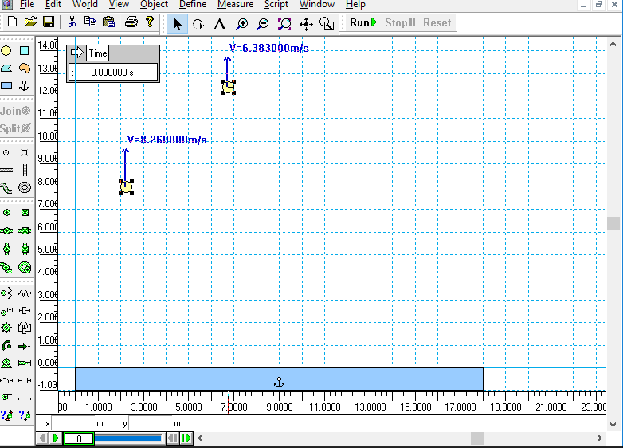

**Fall 1**

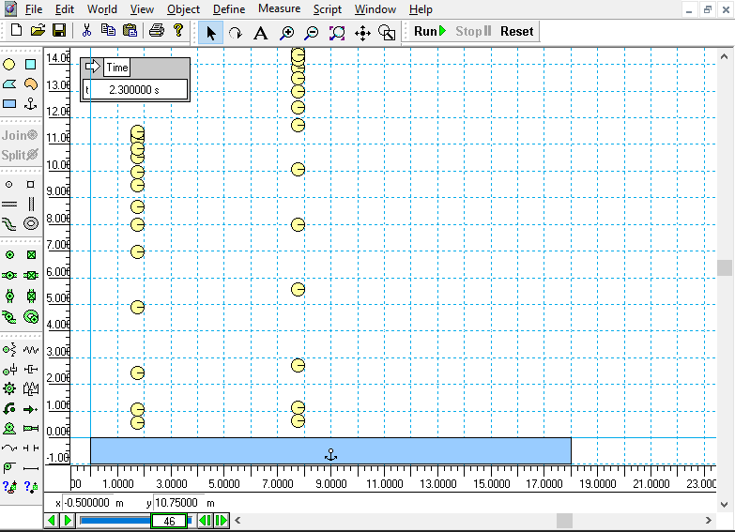

**Different velocity in the X direction:**

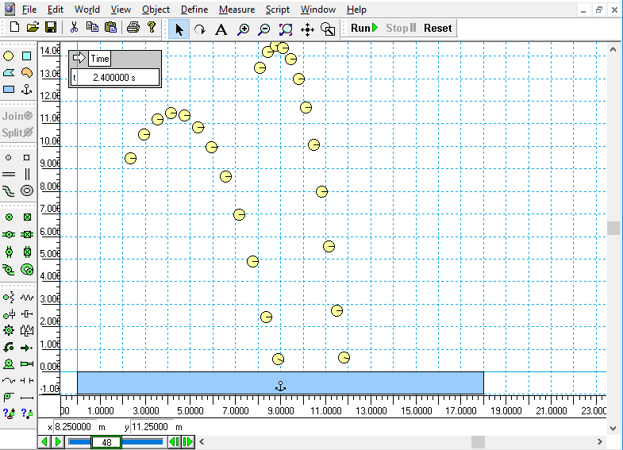

|  |  |  |
| --- | --- | --- |
| Object | Initial Velocity (m/s) | Time (s) |
| Circle 1 | 8.26 m/s | 2.37 s |
| Circle 2 | 8 m/s | 2.37 s |

Part 2

# Initial conditions:

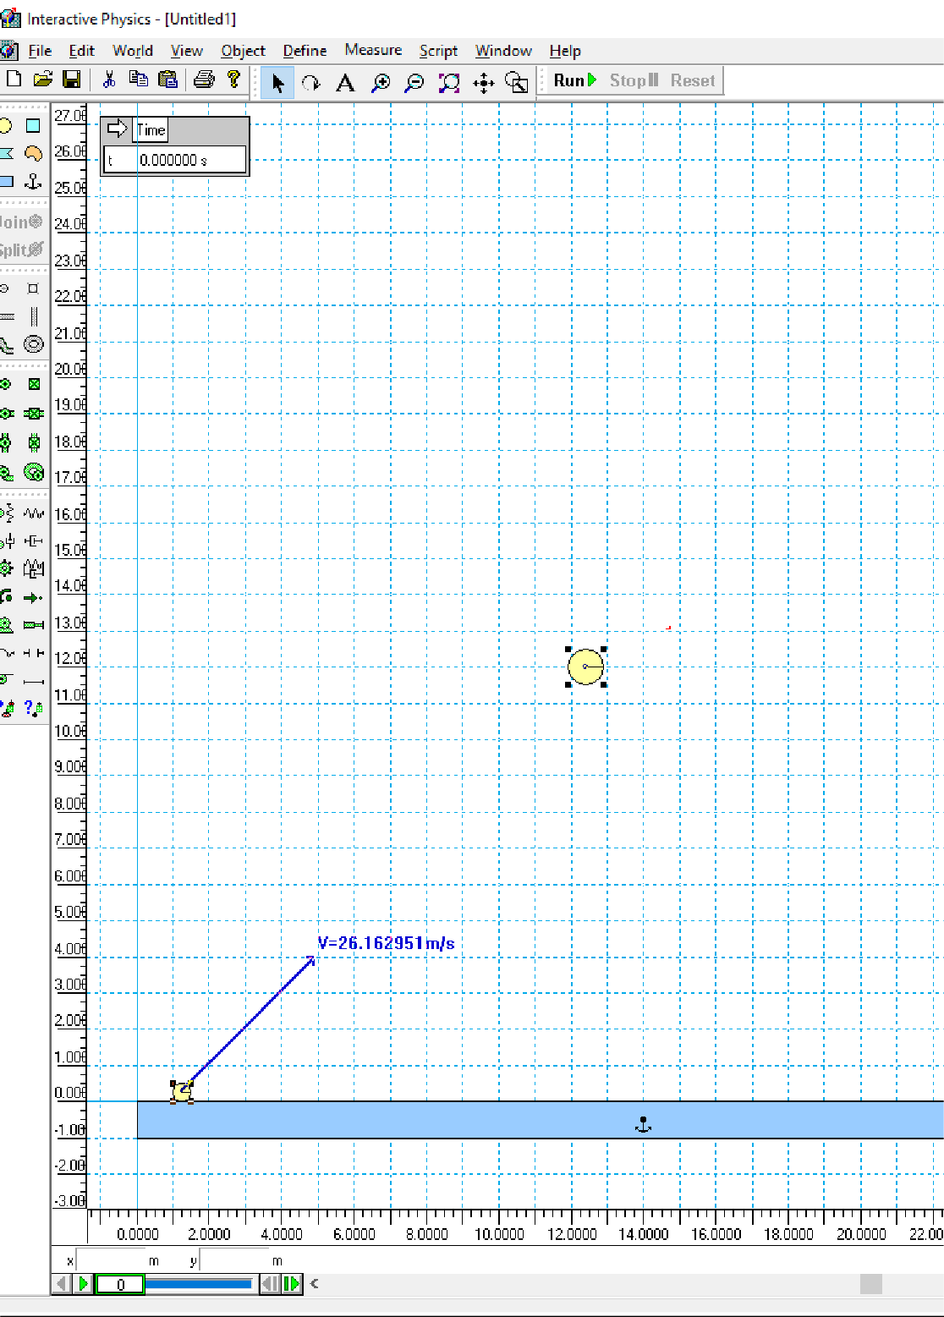

**Collision – During**

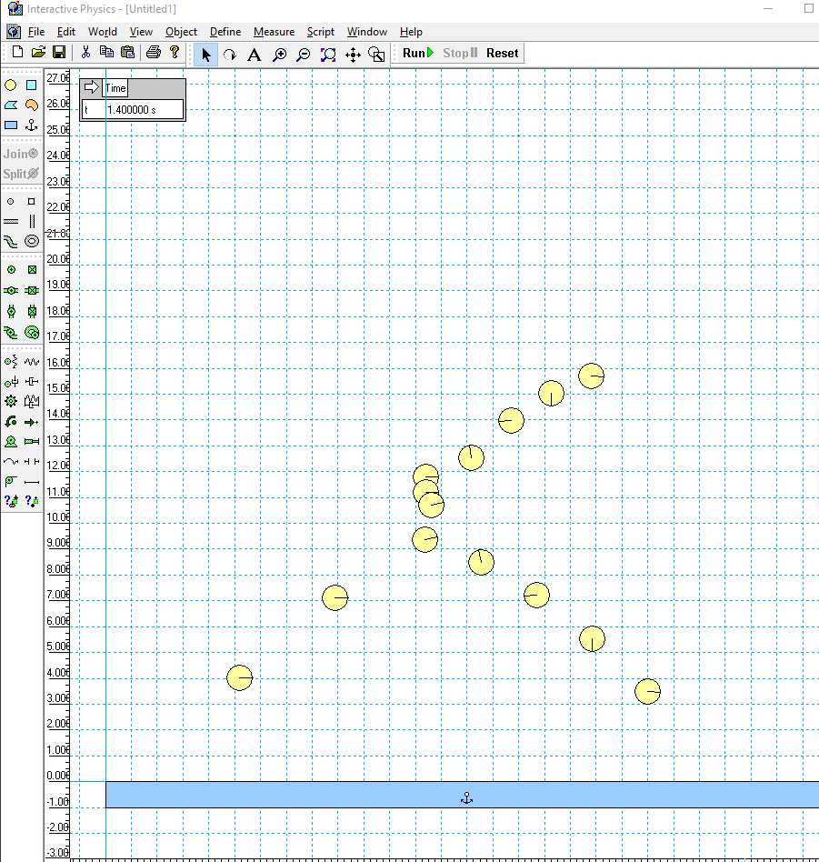

|  |  |  |
| --- | --- | --- |
| Object | Initial Velocity (m/s) | Time (s) |
| Circle 1 | 0 m/s | 1.4s |
| Circle 2 | Vyi = 18.5 m/s & Vxi = 18.5 m/s | 1.4s |

Analysis:

When running the simulations with the with our calculations, they were proven to be accurate. However, the size of the circles does affect the visual collision of the objects during the simulation but that can be explained. The collision would have occurred closer to five if the circles were smaller.

Comments:

When using the simulation program, my team had to change the “sign” for gravity from -9.8 m/s2 to +9.8 m/s2 in order for the circles to fly in the correct direction. However, in our actual equation we used -9.8 m/s2 for the gravity.